|  |  |  |  |
| --- | --- | --- | --- |
|  | **VEDANTA LIMITED –**  **VALUE ADDED BUSINESS** | **Document No.:** | **VL/IMS/VAB/PID1/ELEC/SECT/02** |
| **IMS - DEPARTMENTAL MANUAL** | **Revision Date:** | **04.03.2023** |
| **Introduction** | **Revision No.:** | **00** |
| **Page No.:** | **1 of 2** |

**Introduction:** A blast furnace is a type of metallurgical furnace used for smelting to produce industrial metals, generally iron, but also others such as lead or copper. In a blast furnace, fuel, ores, and flux (limestone) are continuously supplied through the top of the furnace, while a hot blast of air (sometimes with oxygen enrichment) is blown into the lower section of the furnace through a series of pipes called tuyeres, so that the chemical reactions take place throughout the furnace as the material moves downward. The end products are usually molten metal and slag phases tapped from the bottom, and flue gases exiting from the top of the furnace. The downward flow of the ore and flux in contact with an up flow of hot, carbon monoxide-rich combustion gases is a counter current exchange and chemical reaction process. PID-1 is of total load 6.2MW which Is fed from our own captive power plant which has a total capacity of 30MW. Also, at PID 1 we have 3 Caterpillar DG sets of 1944KVA.  
  
Electrical maintenance steers with an objective of keeping all the equipment’s operation streamlined without breakdowns & further withdrawing the peak efficiency out of them while ensuring safety. Moreover the department functions to intercept fluctuation that can occur in the production process.

In IOB- VAB we with our various maintenance management and strategies we ensure Minimal breakdowns & down time to boot production. The department works alongside various other departments such as electrical, instrumentation, projects and business excellence for taking innovative & automated approach that further enhances the system. Innovation, kaizen, latest maintenance strategies, spares management are few of the primary pillars of the department.

Further with our various maintenance activities and total employee involvement, we are set to attain focused results in our employee orientation, customer orientation, shareholder and other stake holder orientations.  
  
**MAINTENANCE.OBJECTIVES**  
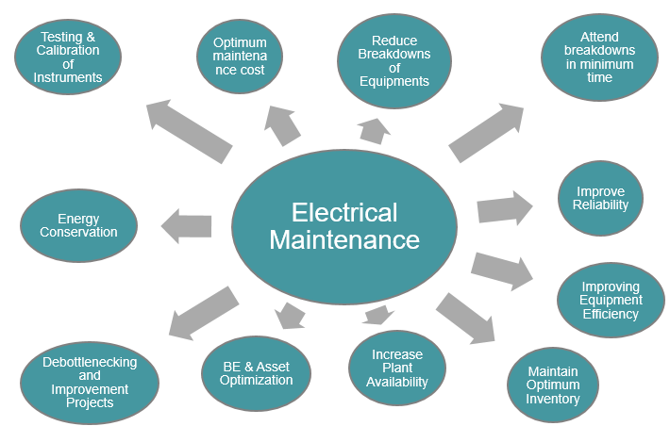

**PID 1 LOAD DISTRIBUTION**  
PID-1 is of total load 6.2MW which Is fed from our own captive power plant which has a total capacity of 30MW. Also, at PID 1 we have 3 Caterpillar DG sets of 1944KVA.  
  
11KV main incomer supply is coming from GEL plant through 2 nos. 240mm2 Al cable.

* To support 11KV power we are having 3 nos. CAT DG set of capacity 1944KVA(Approximate 1.5MW). We can load CAT DG to maximum 1.2MW load.
* CAT DG no 2 & 3 are having provision of start in Auto mode. Generally CAT DG no. 2 is selected in Auto mode & in every shift CAT DG no 2 automation is being checked by Shift engineer.
* During total power failure(11KV power supply from GEL tripped) main 11KV,1250A incomer breaker at PID 1 will tripped and CAT 2 will start in Auto mode. Upon starting of DG in auto mode BF1 blower no. 1, BF2 blower no 1, BF1 Cooling tower pump, BF2 Cooling tower pump, BF1 RWP & BF2 RWP will start in Auto mode. BF1 Blower 3.3KV HT panel is having 2 incomer supply one from 4MVA transformer(Section 1) & second from 3.5MVA transformer(Section 2) with bus coupler arrangement. BF1 Blower no 1,3,5 & 6 are connected in section 1 whereas Blower no 2 & 4 are connected in section 2.
* In case of shutdown or failure of 3.5MVA transformer blower no 2 or 4 can started on section 1 supply after putting OFF 3.5MVA transformer breaker & putting ON Bus coupler breaker.   
  BF2 Blower 3.3KV HT panel is having 2 incomer supply one from 5.5MVA transformer(Section 1) & second from 3.5MVA transformer(Section 2) with bus coupler arrangement. BF2 Blower no 1,2,3 & 6 are connected in section 1 whereas Blower no 4 & 5 are connected in section 2.
* In case of shutdown or failure of 3.5MVA transformer blower no 4 or 5 can started on section 1 supply after putting OFF 3.5MVA transformer breaker & putting ON Bus coupler breaker.

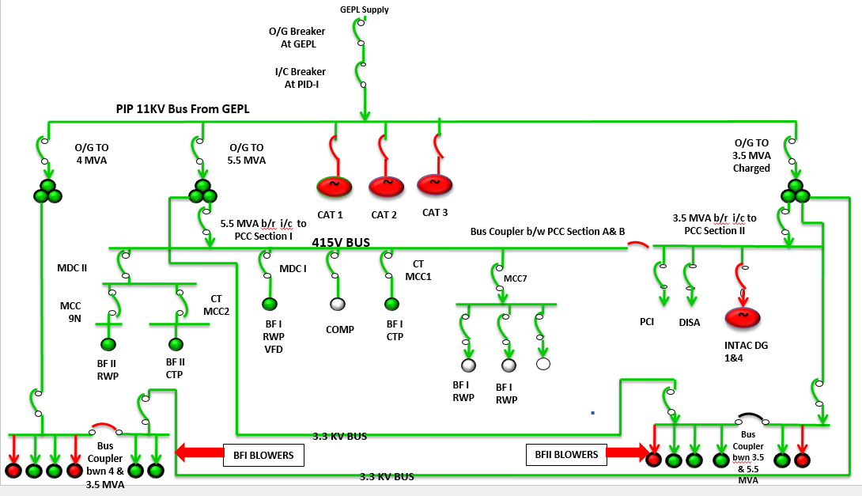  
  
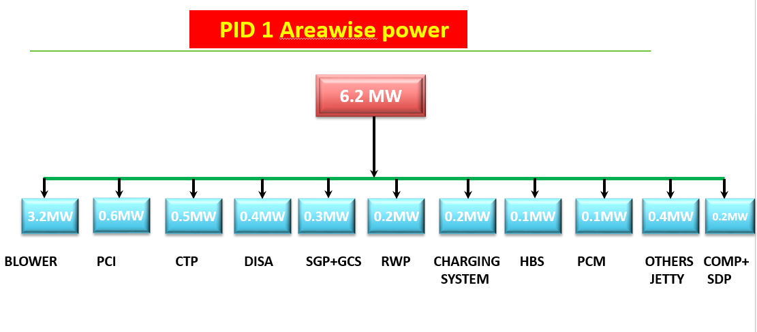  
**PCC Power distribution**  
415V PCC LT panel is having 2 incomer supply one from 5.5MVA transformer 415V(Section A) & second from 3.5MVA transformer 415V(Section B) with bus coupler arrangement.

Connected load on Section A

1. MDC II (Incomer 1)  
2. Cooling tower MCC 1  
3. Project building & BF Compressor no. 1  
4. MCC 7  
5. GCS Section 2 + MDC II (Incomer 2)  
6. MCC 10  
7. MDC 1  
Connected load on Section B  
BF1 Baghouse   
PCI  
INTAC DG  
  
**MDC 1 Power distribution**  
  
MDC 1 415V LT panel has 2 incomer supply one from PCC & second from MCC 10. Both breaker are having Electrical & mechanical interlocking between them

* Connected load on MDC 1

1. MCC 2
2. MCC 9 Section 1
3. Outgoing to BF1 RWP VFD
4. Supply to 200KVAR Harmonic panel

**MDC II power distribution**  
MDC II 415V LT panel has 2 incomer supply one from PCC MDC II & second from PCC GCS section 2 feeder. Both breaker are having Electrical & mechanical interlocking provision.

* Connected load on MDC II

1. MCC 12+Project building+ Jayanti yard
2. Slag drier+ Ladle dumping+ Settling pond
3. Cooling tower MCC 2
4. MCC 2N
5. MCC 9N

2nd supply to MDC II from GCS section 2 is given to cater critical load requirement like BF2 PLC UPS,PCM 3/4, GCS pump no 1/2 during outage of MDC II power supply from PCC (Corrective action

|  |  |  |
| --- | --- | --- |
| **Prepared By:**  Senior Elect. Engineer | **Reviewed & Issued By:**  Management Representative | **Approved By:**  Head – Electrical & Instrumentation PID I |
| **Signature** | **Signature:** | **Signature:** |
| **Review Date: 04.03.2023** | **Review Date: 04.03.2023** | **Review Date: 04.03.2023** |